MISBAH MAJID SHAIKH
ROLL N0: 24
DATA SCEINCE

ASSINGMNET 1 : DATA SCEINCE AND ENVIRONMENT

Q1:

import pandas as pd
df=pd.DataFrame(columns=['Name','Percentage','Age'])
df.loc[0]=['Misbah',79,19]
df.loc[1]=['Sadika',95,20]
df.loc[2]=['Sadiya',70,20]
df.loc[3]=['Adeeba',80,21]
df.loc[4]=['Sara',94,21]
df.loc[5]=['Falak',80,20]
df.loc[6]=['Tehzeeb',87,21]
df.loc[7]=['Iqra',78,20]
df.loc[8]=['Hema',94,21]
df.loc[9]=['Ayesha',73,20]
print(df)

OUTPUT:
Name Percentage Age
0 Misbah 79 19
1 Sadika 95 20
2 Sadiya 70 20
3 Adeeba 80 21
4 Sara 94 21
5 Falak 80 20
6 Tehzeeb 87 21
7 Iqra 78 20
8 Hema 94 21
9 Ayesha 73 20
Q2:

import pandas as pd
df=pd.DataFrame(columns=['Name','Percentage','Age'])
df.loc[0]=['Misbah',79,19]
df.loc[1]=['Sadika',95,20]
df.loc[2]=['Sadiya',70,20]
df.loc[3]=['Adeeba',80,21]
df.loc[4]=['Sara',94,21]
df.loc[5]=['Falak',80,20]
df.loc[6]=['Tehzeeb',87,21]
df.loc[7]=['Iqra',78,20]
df.loc[8]=['Hema',94,21]
df.loc[9]=['Ayesha',73,20]
print(df)
print("the shape:",df.shape)
print("no.of rows,column:",df.size)
print("datatyoes:",df.columns)
print("description:",df.describe)
OUTPUT:

Name Percentage Age
0 Misbah 79 19
1 Sadika 95 20
2 Sadiya 70 20
3 Adeeba 80 21
4 Sara 94 21
5 Falak 80 20
6 Tehzeeb 87 21
7 Iqra 78 20
8 Hema 94 21
9 Ayesha 73 20
the shape: (10, 3)
no.of rows,column: 30
datatyoes: Index(['Name', 'Percentage', 'Age'], dtype='object')
description: <bound method NDFrame.describe of Name Percentage Age
0 Misbah 79 19
1 Sadika 95 20
2 Sadiya 70 20
3 Adeeba 80 21
4 Sara 94 21
5 Falak 80 20
6 Tehzeeb 87 21
7 Iqra 78 20
8 Hema 94 21
9 Ayesha 73 20>

Q3:

import pandas as pd
df=pd.DataFrame(columns=['Name','Percentage','Age'])
df.loc[0]=['Misbah',79,19]
df.loc[1]=['Sadika',95,20]
df.loc[2]=['Sadiya',70,20]
df.loc[3]=['Adeeba',80,21]
df.loc[4]=['Sara',94,21]
df.loc[5]=['Falak',80,20]
df.loc[6]=['Tehzeeb',87,21]
df.loc[7]=['Iqra',78,20]
df.loc[8]=['Hema',94,21]
df.loc[9]=['Ayesha',73,20]
print(df)
print("the shape:",df.shape)
print("no.of rows,column:",df.size)
print("datatyoes:",df.columns)
print("description:",df.describe)

OUTPUT:

Name Percentage Age
0 Misbah 79 19
1 Sadika 95 20
2 Sadiya 70 20
3 Adeeba 80 21
4 Sara 94 21
5 Falak 80 20
6 Tehzeeb 87 21
7 Iqra 78 20
8 Hema 94 21
9 Ayesha 73 20
description: <bound method NDFrame.describe of Name Percentage Age
0 Misbah 79 19
1 Sadika 95 20
2 Sadiya 70 20
3 Adeeba 80 21
4 Sara 94 21
5 Falak 80 20
6 Tehzeeb 87 21
7 Iqra 78 20
8 Hema 94 21
9 Ayesha 73 20>
Q4:

import pandas as pd
df=pd.DataFrame(columns=['Name','Percentage','Age'])
df.loc[0]=['Misbah',79,19]
df.loc[1]=['Sadika',95,20]
df.loc[2]=['Sadiya',70,20]
df.loc[3]=['Adeeba',80,21]
df.loc[4]=['Sara',94,21]
df.loc[5]=['Falak',80,20]
df.loc[6]=['Tehzeeb',87,21]
df.loc[7]=['Iqra',78,20]
df.loc[8]=['Hema',94,21]
df.loc[9]=['Ayesha',73,20]
df['remark']=None
print(df)

OUTPUT:

Name Percentage Age remark
0 Misbah 79 19 None
1 Sadika 95 20 None
2 Sadiya 70 20 None
3 Adeeba 80 21 None
4 Sara 94 21 None
5 Falak 80 20 None
6 Tehzeeb 87 21 None
7 Iqra 78 20 None
8 Hema 94 21 None
9 Ayesha 73 20 None
Q5:

import pandas as pd
df=pd.DataFrame(columns=['Name','Percentage','Age'])
df.loc[0]=['Misbah',79,19]
df.loc[1]=['Sadika',95,20]
df.loc[0]=['Misbah',79,19]
df.loc[2]=['Sadiya',70,20]
df.loc[3]=['Adeeba',80,21]
df.loc[4]=[None,80,22]
df['Remark']=None
print(df)
print("number of observation is:",df["Name"].size)
missing=df.isnull()
print("\n Display missing values:",missing)
dup=df.duplicated()
print(dup)

OUTPUT:

Name Percentage Age Remark
0 Misbah 79.0 19.0 None
1 Sadika 95.0 20.0 None
2 Sadiya 70.0 20.0 None
3 Adeeba 80.0 21.0 None
4 NaN 80.0 22.0 None
number of observation is: 5

Display missing values: Name Percentage Age Remark
0 False False False True
1 False False False True
2 False False False True
3 False False False True
4 True False False True
0 False
1 False
2 False
3 False
4 False
dtype: bool
Q6:

import pandas as pd
df=pd.DataFrame(columns=['Name','Percentage','Age'])
df.loc[0]=['Misbah',79,19]
df.loc[1]=['Sadika',95,20]
df.loc[2]=['Sadiya',70,20]
df.loc[3]=['Adeeba',80,21]
df['remark']=None
df.drop(labels=['remark'],axis=1,inplace=True)
df.dropna(axis=0,inplace=True)
print(df)

OUTPUT:

Name Percentage Age
0 Misbah 79 19
1 Sadika 95 20
2 Sadiya 70 20
3 Adeeba 80 21

Q7:

import pandas as pd
import matplotlib.pyplot as plt
df=pd.DataFrame(columns=['Name','Percentage','Age'])
df.loc[0]=['Misbah',79,19]
df.loc[1]=['Sadika',95,20]
df.loc[2]=['Sadiya',70,20]
df.loc[3]=['Adeeba',80,21]
df.loc[4]=['Sara',94,21]
df.loc[5]=['Falak',80,20]
df.loc[6]=['Tehzeeb',87,21]
df.loc[7]=['Iqra',78,20]
df.loc[8]=['Hema',94,21]
df.loc[9]=['Ayesha',73,20]
df['remark']=None
df.drop(labels=['remark'],axis=1,inplace=True)
df.dropna(axis=0,inplace=True)
print(df)
df.plot(x="Name", y="Percentage")
plt.xlabel("Name VS Percentage")
plt.xlabel("Name of Students")
plt.ylabel("Percentage")
plt.show

OUTPUT:

Name Percentage Age
0 Misbah 79 19
1 Sadika 95 20
2 Sadiya 70 20
3 Adeeba 80 21
4 Sara 94 21
5 Falak 80 20
6 Tehzeeb 87 21
7 Iqra 78 20
8 Hema 94 21
9 Ayesha 73 20
<function matplotlib.pyplot.show(close=None, block=None)>
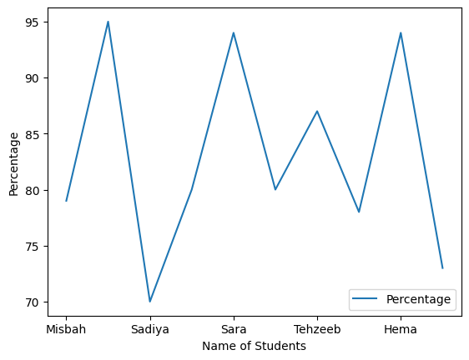

Q7:

import pandas as pd
import matplotlib.pyplot as plt
df=pd.DataFrame(columns=['Name','Percentage','Age'])
df.loc[0]=['Misbah',79,19]
df.loc[1]=['Sadika',95,20]
df.loc[2]=['Sadiya',70,20]
df.loc[3]=['Adeeba',80,21]
df.loc[4]=['Sara',94,21]
df.loc[5]=['Falak',80,20]
df.loc[6]=['Tehzeeb',87,21]
df.loc[7]=['Iqra',78,20]
df.loc[8]=['Hema',94,21]
df.loc[9]=['Ayesha',73,20]
print(df)
plt.scatter(x=df ['Name'],y=df['Percentage'])
plt.xlabel("Name VS Percentage")
plt.xlabel("Name of Students")
plt.ylabel("Percentage")
plt.show
OUTPUT:

Name Percentage Age
0 Misbah 79 19
1 Sadika 95 20
2 Sadiya 70 20
3 Adeeba 80 21
4 Sara 94 21
5 Falak 80 20
6 Tehzeeb 87 21
7 Iqra 78 20
8 Hema 94 21
9 Ayesha 73 20
<function matplotlib.pyplot.show(close=None, block=None)>
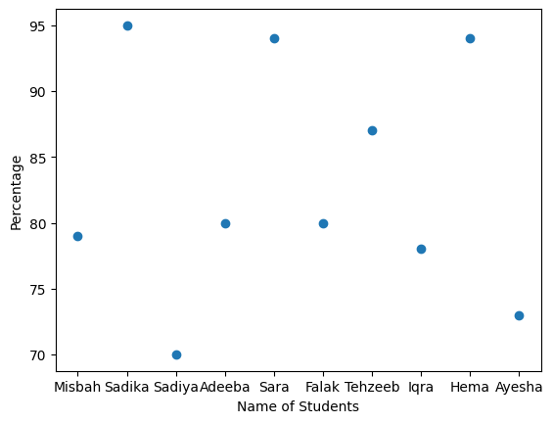
Set B:

Q1:

import pandas as pd
data=pd.read_csv('HeightWeight.csv')
df=pd.DataFrame(data)
print('\n first 10 rows :\n')
print(df.head(10))
print('\n Last 10 rows :\n')
print(df.tail(10))
print('\n Random 20 rows :\n')
print(df.sample(20))

Q2:
import pandas as pd
data=pd.read_csv('HeightWeight.csv')
df=pd.DataFrame(data)
print("\n Shape of dataframe:",df.shape)
print("\n Size of dataframe:",df.size)
print("\n Datatypes from dataframe:",df.dtypes)

Q3:
import pandas as pd
data=pd.read_csv('HeightWeight.csv')
df=pd.DataFrame(data)
print("\n statistical details pf data:",df.describe)

Q4:
import pandas as pd
import numpy as np
data=pd.read_csv('HeightWeight.csv')
df=pd.DataFrame(data)
print("\n Number of observation:",df['Index'].size)
missing=df.isnull()
print("\n Missing Values:\n",missing)
nan_values=np.isnan(df)
print("\n nan value:",nan_values)

Q5:
import pandas as pd
import numpy as np
data=pd.read_csv('HeightWeight.csv')
df=pd.DataFrame(data)
df['BMI']=(df['Weight(Pounds)']/df['Height(Inches)']**2)
print("*****after adding column dataframe is:*****\n",df)

Q6:
import pandas as pd
import numpy as np
data=pd.read_csv('HeightWeight.csv')
df=pd.DataFrame(data)
df['BMI']=(df['Weight(Pounds)']/df['Height(Inches)']**2)
print("\n Maximum of IBM=",max(df['BMI']))
print("\n Minimum of IBM=",min(df['BMI']))

Q7:
import pandas as pd
import matplotlib.pyplot as plt
data=pd.read_csv('HeightWeight.csv')
df=pd.DataFrame(data)
df['BMI']=(df['Weight(Pounds)']/df['Height(Inches)']**2)
plt.scatter(x=df['Height(Inches)'],y=df['Weight(Pounds)'],c='blue')
plt.title("Scatter Plot")
plt.xlabel("Height(Inches)")
plt.ylabel("Weight(Pounds)")
plt.show()

